# Introduction

The analysis at hand explores the intricate relationship between key economic indicators related to the UK economy and their influence on the US GDP. This study aims to unravel how interconnected the global economies are, particularly between the UK and the US.

To achieve this, we have selected a range of variables that are pivotal in representing the economic health and trends of both nations. The variables include the US GDP, an aggregate measure of US economic activity; the All UK Shares Index, reflecting the performance of the UK stock market; the USD/GBP exchange, which is crucial in understanding the economic relationship and trade dynamics between the two countries; the UK Consumer Price Index, indicating the inflationary trends in the UK; and the UK GDP, offering a direct comparison with the US GDP.

The choice of these variables is grounded in the hypothesis that the UK’s stock market performance, inflation rates, currency strength, and overall economic output have a tangible impact on the US economy. These variables are not only indicators of domestic economic health but also serve as signals influencing international investment, trade policies, and economic decisions in the US.

The observation period for this study spans from January 1990 to November 2023. This extended period allows for a comprehensive analysis of long-term trends and cyclical behaviors, including periods of economic booms, recessions, and recovery phases in both economies. The choice of a quarterly frequency for data collection strikes a balance between capturing short-term economic fluctuations and smoothing out the noise present in higher-frequency data (like monthly or daily data).

By log-transforming the data, we aim to stabilize variance and improve the interpretability of our models. Log transformations are particularly useful in financial time series analysis, as they convert multiplicative relationships into additive ones, simplifying the understanding of elasticities and relative changes.

This study is designed to provide insights into how key indicators of the UK economy influence the US GDP, using a robust dataset spanning over three decades, and employing log-transformations to facilitate a clearer analysis of the complex relationships between these variables.

## Trend and Seasonality Decomposition of The Log Transformed series.

Once the variables are log-transformed, we perform a decomposition of the time series to analyze their different components.

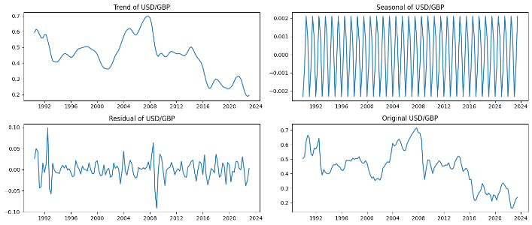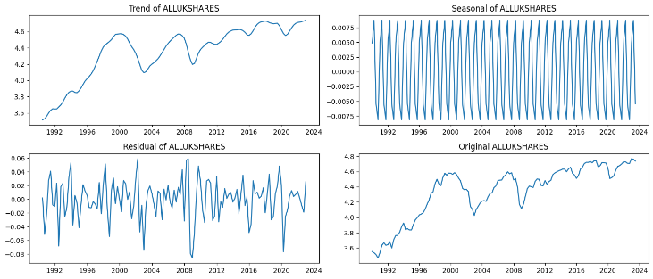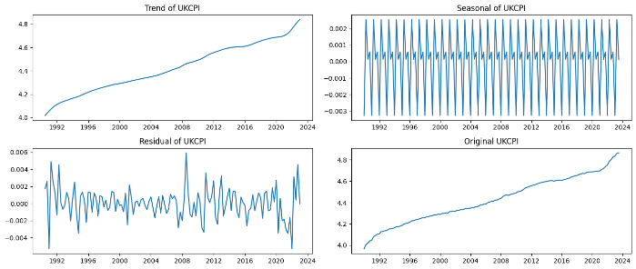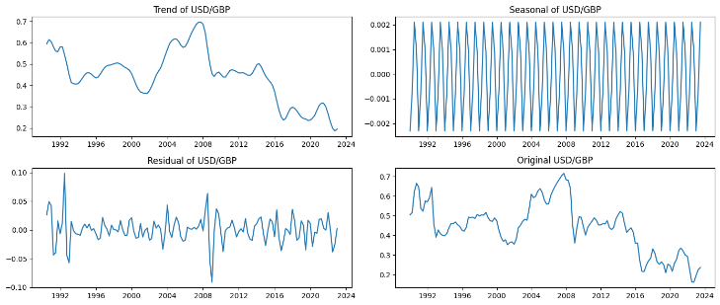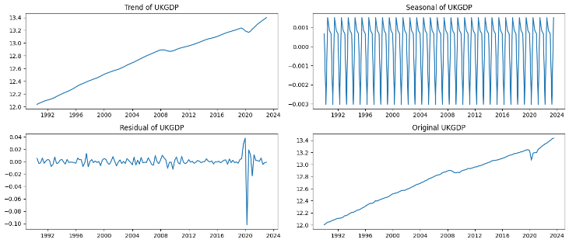

For UKGDP, there's a clear upward trend over the years, indicating growth. The seasonal plot shows regular fluctuations within each year, while the residuals suggest most variations are explained by the trend and seasonality, with some notable exceptions, especially a significant deviation around 2020.

The USD/GBP exchange rate exhibits a more complex trend with rises and falls, not showing a clear long-term direction. The seasonal effect is very regular, almost mechanical, which is unusual for financial data and may suggest data issues or the effect of consistent market patterns. Residuals are more volatile, indicating less predictability and more unexpected variations than seen in the UKGDP.

ALLUKSHARES also shows a growth trend with some volatility, particularly around the financial crisis of 2008 and again around 2020. The seasonal plot shows less clear periodicity than in the UKGDP and USD/GBP plots, which could be due to the inherent volatility of the stock market. Residuals are notably more erratic, reflecting the unpredictable nature of stock prices.

Lastly, UKCPI shows a steady increase over time, reflecting inflationary trends. The seasonal effect is again very regular, and the residuals show some spikes, likely reflecting economic events impacting inflation rates.

These decompositions are valuable for understanding underlying patterns and outliers in economic data and can inform economic forecasting and policy decisions. The notable deviations in residuals around 2020 across different variables likely correspond to the economic impact of the COVID-19 pandemic.

# Check for drift and deterministic trend.

# n assessing the time series for evidence of non-stationarity, we conducted tests to formally confirm the presence of trends and drift. The regression of each variable against time has revealed a unit trend coefficient for all, confirming a deterministic trend in each series. The drift coefficient, however, is notably small for USGDP, ALLUKSHARES, and UKGDP, leading to a rejection of drift in these series. Interestingly, USD/GBP shows a positive drift coefficient, affirming both trend and drift, indicative of a stochastic trend. These results validate our visual assessment and provide a robust foundation for further econometric modeling, including the need to difference or detrend the series in preparation for ARIMA/VAR analysis to achieve stationarity.

# Seasonality Check on the level data

We use the Kruskal-Wallis test, a non-parametric method for testing whether samples originate from the same distribution, applied to various economic series to determine if there is seasonality present in the data.

Overall, the high p-values (all greater than 0.05) across all series suggest that there is no statistical evidence of seasonality in any of the time series datasets according to the Kruskal-Wallis test.

# Detrended data analysis

To remove the time trend, we choose to estimate a least-squares fit of a straight line to the data and to subtract the resulting function from the data.

Below are the detrended series.

## Check the seasonality on the detrended data.

We check for the existence of seasonality in the detrended data. Again, as it is the case with the data pre-detrending, the detrended data presents no significant seasonality.

## Check the differencing orders needed to make the series I (0)

The table presented in the image shows the Augmented Dickey-Fuller (ADF) Test Results for Stationarity for a series of economic indicators. The ADF test is a common statistical test used to determine whether a time series is stationary or if it possesses a unit root, which implies non-stationarity. The term "stationary" here means that the statistical properties of the series such as mean, variance, and autocorrelation are constant over time.

According to the table, each series was subjected to a first-order differencing to achieve stationarity. The ADF statistic values are provided for each series, with more negative values indicating stronger evidence against the presence of a unit root. The p-values associated with these statistics tell us the probability of observing such results if the null hypothesis of a unit root was true. For all the series listed, the p-values are very low, well below the 0.05 threshold commonly used in statistical hypothesis testing.

Furthermore, the table confirms that each series is stationary at the 5% level, meaning that with 95% confidence, we can say the series do not have a unit root and are thus stationary after first-order differencing. This is a critical finding for econometric modeling since non-stationary data can lead to unreliable and spurious regression results. Therefore, the analysts can proceed with their econometric analysis on the basis that these indicators are indeed stationary and do not contain a unit root, having adjusted them appropriately through differencing.

## Differencing the detrended series:

# Use an ARIMA

## Find the best order.

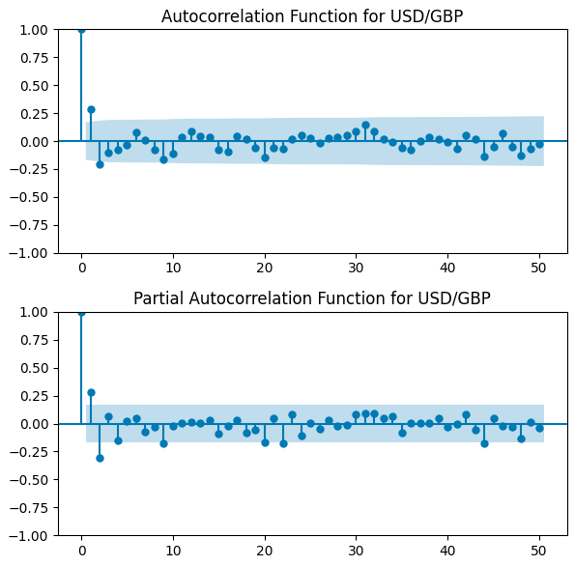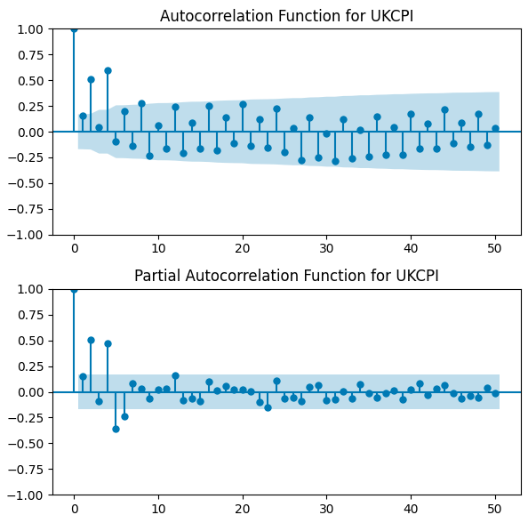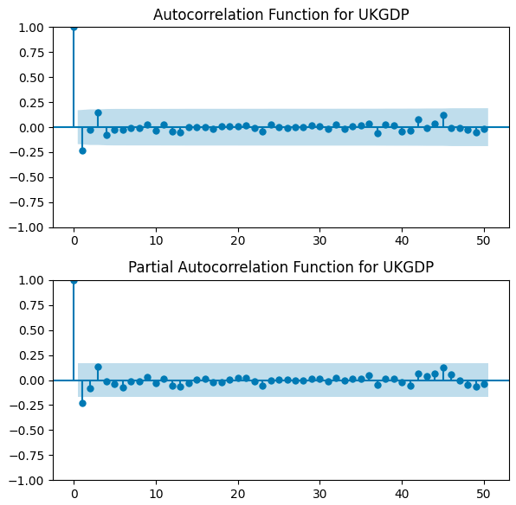

Most AR and MA parameters indicators for all varables imply a 1 order lag, except for the CPI which implies a 4 order lag for the MA and 6 order lag for the AR.

## Predict the US GDP growth using an ARIMA.

# FE2:

We continue our analysis using the same data from the first empirical assignment using the detrended data. Our goal is to apply a VAR model and model the impact of the UK economy on the US GDP level data and growth.



## Check co-integration between detrended level data.

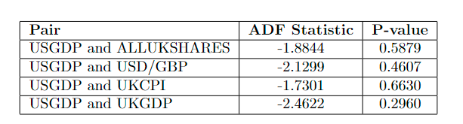

The statistical results indicate that for the variables considered—index, USGDP, ALLUKSHARES, USD/GBP, UKCPI, and UKGDP—there is no substantial autocorrelation. The H-statistics are very low across the board, and the high p-values do not provide enough evidence to reject the null hypothesis of no autocorrelation. Even the highest H-statistic found in UKCPI does not correspond with a low enough p-value to be deemed statistically significant. Overall, these results suggest that past values of these variables do not have a significant predictive power on their future values within this dataset.

## Find the best orders for the VAR.

When selecting the order of a Vector Autoregression (VAR) model, several criteria are commonly used: Akaike Information Criterion (AIC), Bayesian Information Criterion (BIC), Final Prediction Error (FPE), and Hannan-Quinn Information Criterion (HQIC). The optimal order is typically chosen as the one that minimizes these criteria.

**Level Data (Non-Differenced Data)**

AIC: Minimum at order 9

BIC: Minimum at order 1

FPE: Minimum at order 6

HQIC: Minimum at order 2

**I(0) Data (First-Differenced or Stationary Data)**

AIC: Minimum at order 5

BIC: Minimum at order 0

FPE: Minimum at order 5

HQIC: Minimum at order 1

**Interpretation and Model Selection:**

Level Data: There is no single order that minimizes all criteria. AIC suggests a higher order (9), while BIC and HQIC suggest lower orders (1 and 2, respectively). BIC and HQIC tend to favor simpler models compared to AIC, which can be an advantage in avoiding overfitting.

**I(0) Data**: Again, there's no consensus across all criteria. However, both AIC and FPE agree on order 5, while BIC and HQIC suggest lower orders.

## Forecasts

### For level data

### Forecast For first difference data.

## IRF plots and interpretation

The first plot represents the response of US GDP to its own shock. It is typical in such analyses to include the response of a variable to itself as a baseline. The response typically starts with a significant change that diminishes over time, eventually stabilizing.

In the second plot, we see the impact on US GDP following a shock to all UK shares. This could be interpreted as the US economy’s sensitivity to fluctuations in the UK stock market, reflecting financial interconnectedness between the two economies.

The third plot examines the effect of a shock in the exchange rate between the US dollar and the British pound on US GDP (a positive shock implies a rise of the USD relative to GBP). Exchange rate movements can influence trade balances, investment flows, and inflation, among other economic factors, which in turn affect GDP.

Next, there is a plot showing how a shock to the UK Consumer Price Index (CPI) impacts US GDP. The UK's CPI is a measure of inflation, and the plot suggests a potential transmission mechanism where inflationary pressures in the UK might have repercussions on the US economy.

Finally, the last plot illustrates the response of US GDP to a shock in UK GDP. This indicates the extent to which economic developments in the UK can influence economic activity in the US, possibly through trade, investment, or financial markets.

Each plot features a solid line indicating the estimated impulse response and dashed lines that represent the confidence intervals. These intervals provide a range within which the true impulse response is expected to lie with a certain level of confidence. If the confidence intervals cross the horizontal axis, it implies that the estimated response is not statistically significant at those points. The blue solid line is the point estimate of the response at each time period, while the black dashed lines likely represent the confidence intervals, showing the statistical uncertainty of the estimates. The precise interpretation of these plots would depend on the larger context of the analysis, such as the model specification, the data used, and the period under study.

# Conclusion

Our comprehensive VAR analysis has revealed significant dynamic interrelationships between key UK economic indicators and US GDP over the period from 1990 to 2023. The impulse response functions indicate that shocks to UK GDP and CPI have discernible, albeit transient, effects on US GDP, while exchange rate volatility and stock market fluctuations demonstrate a more nuanced impact. These findings underscore the intricate financial and economic ties between the UK and the US.